

**Discipline**

**Algorithm**

***(3 versions)***

**CS5201**

Stage-2

**Sheikh Muhammed Tadeeb (AU19B1014)**

* **Indexing:**

An index is an on-disk structure associated with a table or view that speeds retrieval of rows from the table or view. An index contains keys built from one or more columns in the table or view. These keys are stored in a structure (B-tree) that enables SQL Server to find the row or rows associated with the key values quickly and efficiently.

* **Types of Indexing:**

1. Primary Indexing: - Indexing done on primary key of table is called primary indexing.
2. Secondary Indexing: - Indexing done on Alternate key of table is called primary indexing.
3. Cluster Indexing: - Indexing done on some other column of table apart from primary key where records may have repeating values is called cluster indexing.
4. Multi-level Indexing: - Indexing inside indexing is called multi-level indexing. If the data is big machine does this.

* **Table Insights:**
* **Goods Table:**

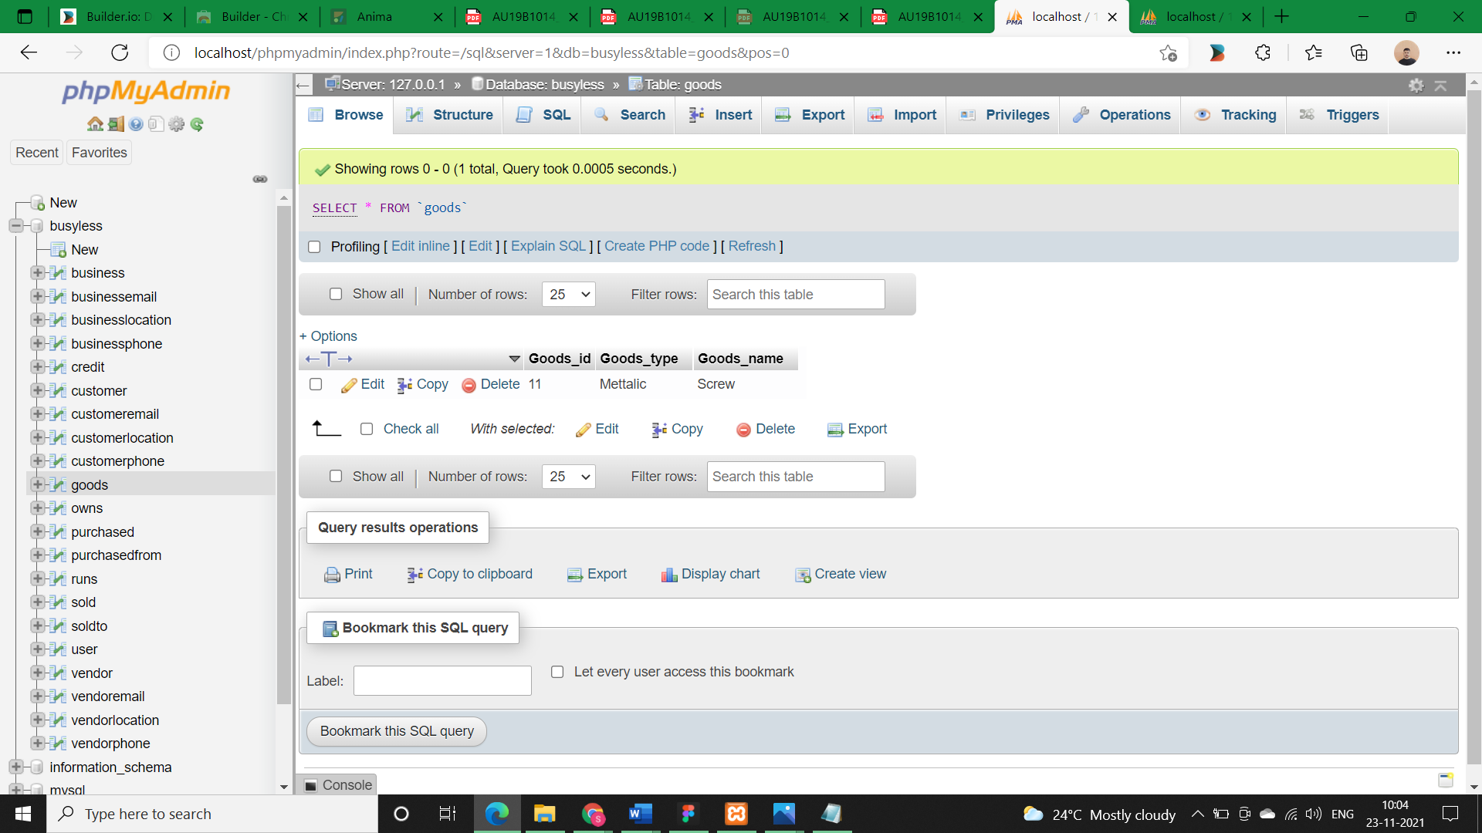

* **Customer Table:**

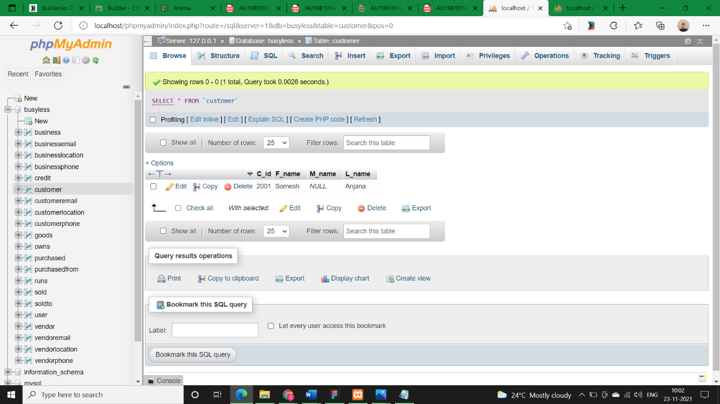

* **Indexing on table:**

|  |  |  |  |
| --- | --- | --- | --- |
| **Snos** | **Primary Indexing** | **Secondary Indexing** | **Cluster Indexing** |
| **1.** | Goods_id | username | - |
| **Description:** | Goods_id is the primary key of the table. There will be many goods in the shop whose quantity will grow as the business grows and so will the operations complexity henceforth indexing is very necessary to reduces the time complexity. | username is the alternate key of the table i.e.; it will also have unique plus not null values but it’s not declared as the primary key of the table. | - |
| **2.** | C_id | - | first_name, last_name |
| **Description** | C_id (customer_id) is the primary key of the table. There will be many customers of the business and as business grow so will the customers and operations complexity as well henceforth indexing is very necessary to reduces the time complexity. | - | On column first_name, last_name, status, password and gender as these columns may have repeating values for two different entries. |

* **Queries (Before Indexing):**
* **Goods table:**

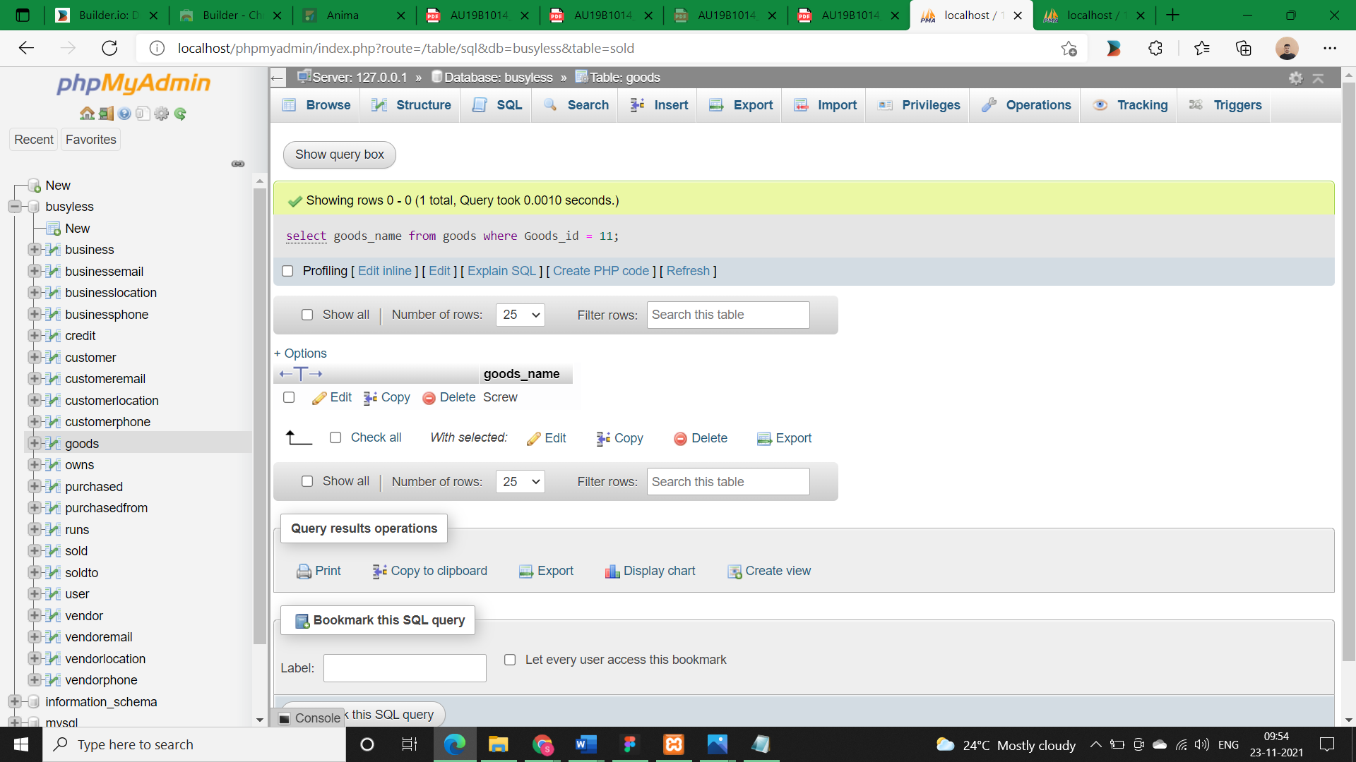

**We can see the time complexity before applying indexing in the above image.**

* **Customer table:**

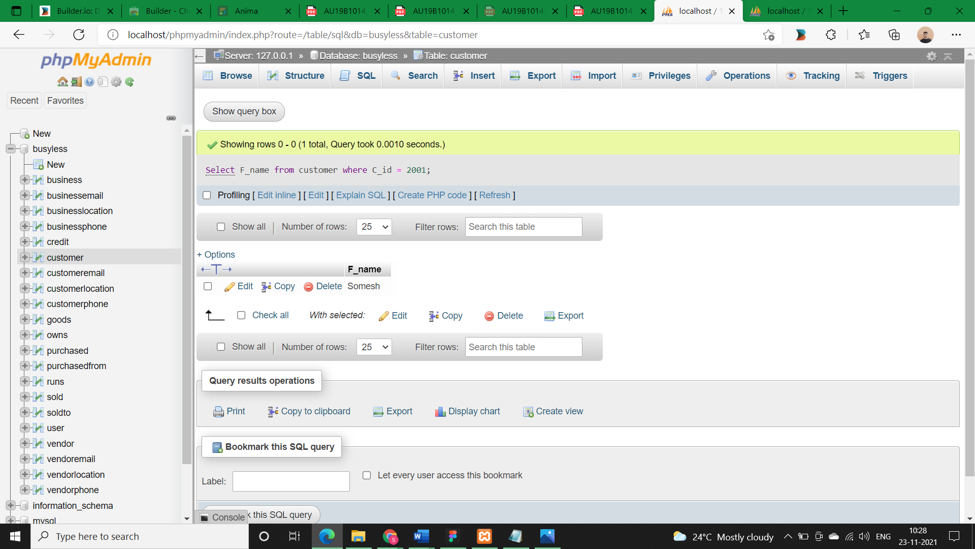

**We can see the time complexity before applying indexing in the above image.**

* **Indexing on table:**
* **Goods Table:**

1. **Primary indexing:**

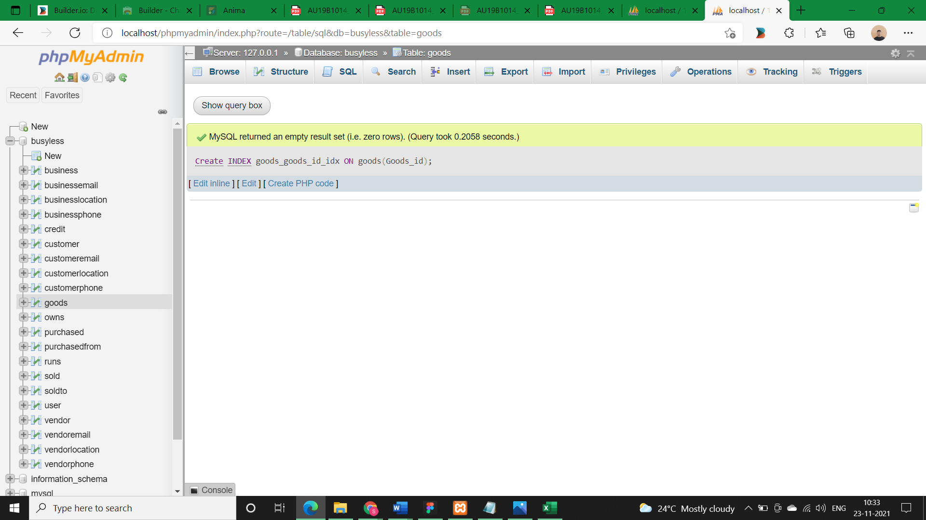

* **Customer Table:**

1. **Primary indexing:**

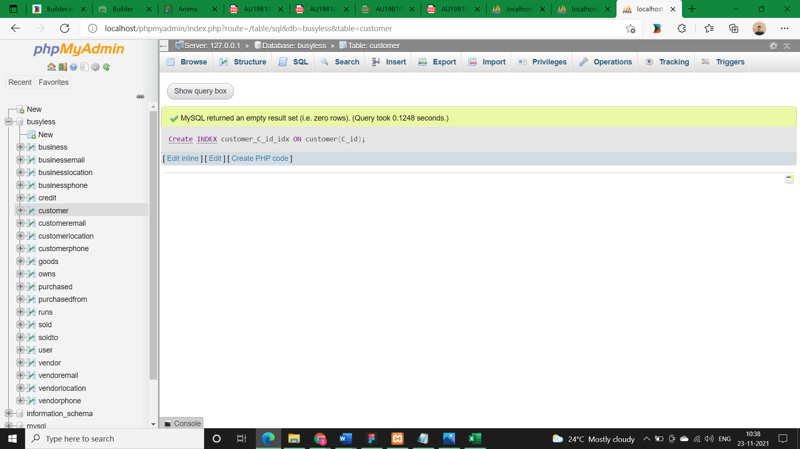

* **Queries (After Indexing):**

As our records will grow then indexing will be very helpful as it will reduce our time complexity.